CASE STUDIES OF

THE UNIVERSITY IN HISTORY

THE STAR PUPIL OF PLATO'S ACADEMY,
CLASSICAL ATHENS

© Robert Pascoe 2001. This case study is prepared for the purposes of discussion, research and study. It does not represent the views of the administration of the university in question. This case study was supported financially by Victoria University, Melbourne, as the author’s employer. Feedback is sought and alternative views welcome. Thanks to Ron Ridley and to Chris Wood for all their help.

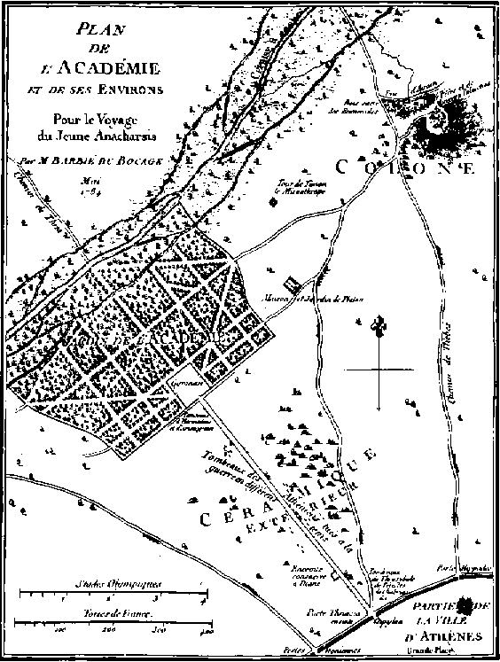
Part A

It was the year 347 BC. Athens was a prosperous and well-ordered city-state, its free citizens supported by a slave underclass that catered for their material needs. The year before, 348 BC, Plato had died. Plato was the philosopher whose thinking and talking best epitomised the values for which Athens stood. It was a communitarian society whose male citizens belonged to a radical direct democracy.

In 347 BC Aristotle completed his 20 years of study at Plato's Academy. He was its star pupil.

This was a society propelled by the oxygen of ideas. The sophists were the first university professors; they lectured superbly and provided answers (often too readily) to the pressing questions of the day. Isocrates opened his school in 393; Plato started his rival school in 387. (Castle 1961: 56)

The curriculum was not fixed, but changing and contestable by the participants: Plato’s Academy was a place which institutionalised ‘the Socratic method’. It is no exaggeration to say that Socrates, Plato and Aristotle developed a means of generating knowledge, and putting it to use, which would remain the dominant European paradigm until Descartes.

It was in ancient Greece that the development of ‘social knowledge’ took place. In other civilisations, knowledge was carefully controlled and no broader applicability of knowledge was available for the wider society to draw from. In these societies the elite typically drew its cadre group from slaves of people it had defeated in war, or from some other closely defined group. Education in the rules and customs of the society was understood in very instrumental terms. This kind of knowledge is mere technical knowledge, and throughout history the graduates of these courtier schools have been no more than technicians, whose skills and abilities were carefully prescribed.

Socrates

Born in Athens in 470 BC, Socrates served as an infantryman in the First Peloponnesian War (431-421 BC). It was as a result of the trauma of this military experience that as a comparatively older man he took up his role as a freelance philosopher, teaching in the gymnasia and in the agora, the open meeting place beneath the Acropolis. Socrates remained a person of meagre personal belongings. He also did not commit his ideas to writing. What we know of his teaching has been deduced from later writers, especially Xenophon in his Memorabilia and Plato in various accounts.

Where Plato’s ideas end and Socrates’ start is difficult to know. The literature on the vexed question of disentangling the ideas of Socrates from those of his pupil is huge. (Nails 1995) Socrates contended that there could be no authentic knowledge of the world without a vigorous interrogation of everything his contemporaries in fifth-century Athens took to be ‘real’. Plato’s account of Socrates is controversial, because it is impossible to determine precisely whether Plato’s reconstruction of Socrates’ dialogues is exactly true in all respects, or merely a restatement of Plato’s own views.

Socrates was a freelance philosopher whose main classroom was the public square known as the agora. This was the same venue as the public debates in which Athenians were well versed. With a teaching style that required his students to proceed by critical dialogue, ‘the Socratic method’, he taught that the good life was to be found by perfecting one’s soul, and that it was the business of government to care for the souls of its citizens. This idealistic conception of the role of the state made him a critic of Athenian democracy, for he did not accept that all views were equal in worth. In fact, ironically, none of the intellectuals for which Athens is remembered were sympathetic to democracy, even though it had given them the opportunity to do well and later voted them a salary.

The famous trial and execution of Socrates took place in 399 BC, when he was 70. Since we only have his defence, as retold by Plato, the evidence for his corrupting the youth and for impiety is not known. If we examine the content of Socrates’ philosophising, rather than his style (or method), the causes of his death-sentence at the hands of the Athenians may not be difficult to ascertain. It is at least conceivable (see I.F. Stone) that he was involved with the anti-democratic conspiracies which interrupted the city-state’s regular democratic processes in 411 and 404.

An extract from Socrates’ speech at his trial, 399BC
O Athenians, I am far from pleading, as one might expect, for myself; it is for you I plead lest you should err as concerning the gift of God given unto you, by condemning me. If you put me to death you will not easily find another of my sort, who, to use a metaphor that may cause some laughter, am attached by God to the state, as a kind of gadfly to a big generous horse, rather slow because of its very bigness and in need of being waked up. As such and to that end God has attached me to the city, and all day long and everywhere I fasten on you, rousing and persuading and admonishing you…

Be not angry with me speaking the truth, for no man will escape alive who honourably and sincerely opposes you or any other mob, and puts his foot down before the many unjust and unrighteous things that would otherwise happen in the city. The man who really fights for justice and right, even if he expects but a short career, untouched, must occupy a private not a public station…(MacArthur 1995 : 10)

Plato and the Academy

The key figure in the transition from freelance philosophers to an institutionalised form of learning was Plato, who put into written form the ‘Socratic method’, the critical method of his mentor. Plato was born in 428 to an aristocratic family, and was thus still quite young when he witnessed the death of Socrates.

The founding of the Academy in 387 BC (when he was aged about 40) coincided with Plato’s return from his first trip to Sicily, to visit the Pythagoreans. Plato is regarded as the inventor of philosophy as it is understood in the West, but obviously was in turn influenced by earlier thinkers, particularly Socrates. (Kraut 1992) The Pythagoreans comprised both akousmatics and mathematikoi, the latter living as a community at Croton. Women were welcome among the mathematikoi, a tradition followed by Plato when he established his Academy. (Wertheim 1995:22-24).

Plato’s Academy was open to all, men and women. There were no fees. During the morning formal classes were held, while the afternoons were given over to public lectures. Although designed particularly for Athenian citizens, the Academy drew students from all parts of the classical world. Again it was this openness to students from outside the ruling elite of Athens that gave the Academy another attribute akin to that of universities.
In all Plato wrote 36 books, constructed in the form of dialogues involving real characters (not only Socrates, but also Parmenides and Timaeus) whose views he purported to transcribe. This was not only perhaps a logical step from the narrative of the oral form to the more studied style of prose writing, but it was also a useful way of advertising the style of debates at the Academy.

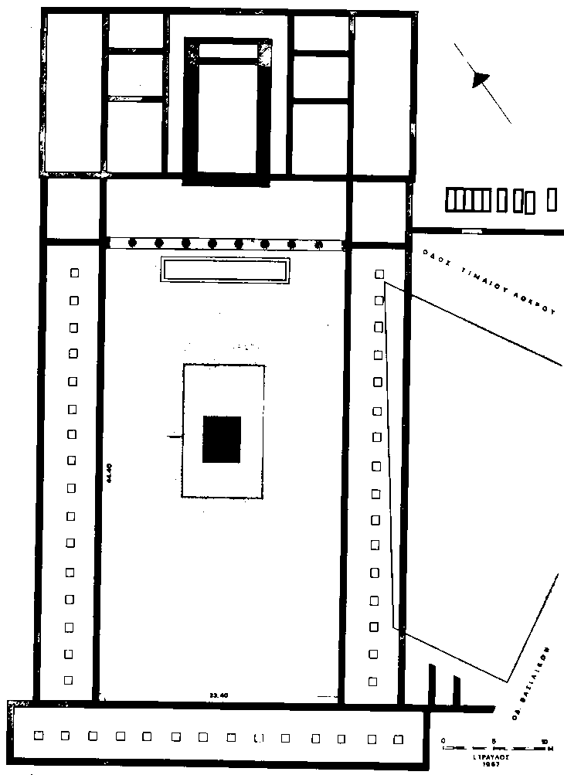
The Gymnasium at the Academy (Travlos)

Everything Plato wrote has survived; from Aristotle and others we also have reports of his teaching style at the Academy. These accounts are important, because Plato understood philosophy as an interactive process--embodying the so-called ‘Socratic technique’. In Plato’s view, the written word by comparison is relatively inflexible and has to assume a common audience. The style of debate taught by Socrates valued disagreement. Indeed, Aristotle’s well-known opposition to Plato’s theory of the Forms shows that the Academy was a place of disagreement and dialogue. Similarly, Aristotle’s Metaphysics, Books XIII and XIV, are replete with accounts of mathematics disputes at the Academy. The holistic approach to knowledge was a by-product of creating an Academy of this kind (and was perhaps an example of group think).

Some lecturing took place, but discussion would have been the predominant form of study. The subjects were broad, including mathematics (number, geometry, stereometry, mathematical astronomy, harmonics), dialectic, and biology. Plato provided leadership in mathematics by asking the right questions, for instance, through observations of the movement of the heavenly bodies. ‘Metrology’, geometry, optics, mechanics are singled out by one writer as areas where real progress was made. By metrologia is meant the ‘theory of measurement’. In other words, the Academy was not merely ‘Platonic’, but dealt with practical subjects such as mechanics. There is some evidence, though fragmentary, that the Academy made interventions into the Greek political world (see the Seventh and Eighth Letters in particular).

Plato certainly developed detailed policy prescriptions on how the state might introduce the kinds of reform desired by Socrates, particularly how it might remove egoism from the community. Men and women were to be treated equally, particularly in education; marriages were to be arranged by the government and children were to be separated from their biological parents; people were to live simply and without extravagances.

Reality could be understood only through the kind of philosophical introspection that separated the apparent multiplicity of the world from its actual structure as a set of universal forms: all things of beauty, for instance, contained the universal known as beauty within them.

The concept of the Academy belonged to a society which permitted a significant extent of public negotiation over matters of person and property. Athens was based on what later came to be recognised as a public legal system. Disputes were resolved not by the traditional (pre-classical) method of blood loyalty, the proverbial eye for an eye method of distributing justice, but by the radically new model of an appeal to abstract principles of right and wrong. For this model to operate required that the protagonists have considerable skills in the art of public pleading, of rhetoric. Rhetoric was at the centre of the Academy’s curriculum.

In short, the Greeks had invented what many see as the first university, Plato’s Academy. It functioned as a centre of intellectual inquiry and provided a counterpoint to civil society. These were revolutionary ideas. Students came from all across the Greek world to study at Plato’s Academy. There were no fees charged. The Academy could be best described as a community of self-supporting intellectuals. Curriculum could not have been exactly as described in Book VII of the Republic, since that imaginary world assumed 30 years of training was required to become a philosopher-king.

The Academy took its name from a nearby park sacred to the hero Academus on the outskirts of Athens. Two millenia later, it is at the corner of Telephonous and Aimonos Streets, a few km to the north west of the Acropolis. The Academy was a public area, and Plato taught out in the public space (presumably outdoors). Nearby he also established a residence, which too was called the Academy.

The site of the Academy was discovered by archaeologists in 1930. In 1997 the Greek Government announced the creation of an urban park running from the Acropolis, through the Agora, the Keramikos cemetery (Plato’s apparent resting-place), the columns of Olympian Zeus, and the Olympic stadium, all the way to the site of Plato’s Academy. Tourists will be able to walk right through the city centre, just as the ancients did, unimpeded by cars.

In 367 Aristotle joined the Academy in its 20th year of operation--and stayed 20 years, until 347. Aristotle was born in 384 in Stagira on the Halkidiki peninsula; his father was the physician to the Macedonian royalty. Then in 347 came the news that he would not succeed Plato as the head of the Academy.

What should Aristotle do? What options did he have?

Part B

Perhaps Aristotle’s departure--to form his own school, the Lyceum--signalled a quarrel with Plato’s successor, his nephew Speusippus, or a regret that he had not himself succeeded his mentor as head of the Academy. Plato had died in the previous year, 348; his last two decades was the period of his late Dialogues. When he was denied the headship of the Academy he and Xenocrates went travelling, making important scientific observations and developing a preference for active experiment which challenged the Platonic style of knowing through reasoning.

It was Aristotle who devised the rules of logic, particularly the syllogism, which served Western thinking for two millenia. When the headship of the Academy next came available, it was Xenocrates and not Aristotle who was chosen. With help from the Macedonian king Alexander (whom he had tutored) he established the rival Lyceum when he was almost 50 (in 374 BC). He taught there for 12 years, until, subjected to a trial similar to that which had bedevilled Socrates, he left Athens, dying a year later, aged about 62. Of his 170 books, only 47 remain. Footage of Aristotle’s Lyceum.
Unlike Pythagoras and Plato, Aristotle did not encourage women at his Lyceum.

About 2 km away is Aristotle’s Lyceum, unearthed in 1997. (Smith 1997: 36). Plato’s immediate successors as scholarch were, in order: Speusippus, Xenocrates, Polemon, Crates (died about 276 BC), and Arcesilaus. The pagan schools were closed by Justinian in 529 AD. In all, then, the Academy lasted 916 years.

The philosophy schools of Classical Athens. [Map from M.L. Clarke] During the Hellenistic period the eastern Mediterranean became suffused with Greek learning of the kind developed in Classical Athens.

Literacy levels rose across the Hellenistic area. References in the surviving manuscript material to Homer's epic poetry can be used as evidence of the range and extent of this new interest in learning. (Morgan 1998)

During the Hellenistic period--roughly the last three centuries before Christ--the university curriculum took on a shape that would be maintained for hundreds of years, into the medieval era.

Other institutions of higher learning developed outside Athens. The Museoin of Alexandria, at the NW extremity of the Nile Delta, facing the Mediterranean coast, was a complex of schools, laboratories, observatories and the Great Library. This Museion was copied from Plato's Academy. Its librarian was an appointee of the king for life, beginning with Zenodotus in 284 BC. The collection reached 490,000 scrolls in volume and thus overtook Athens in prestige.

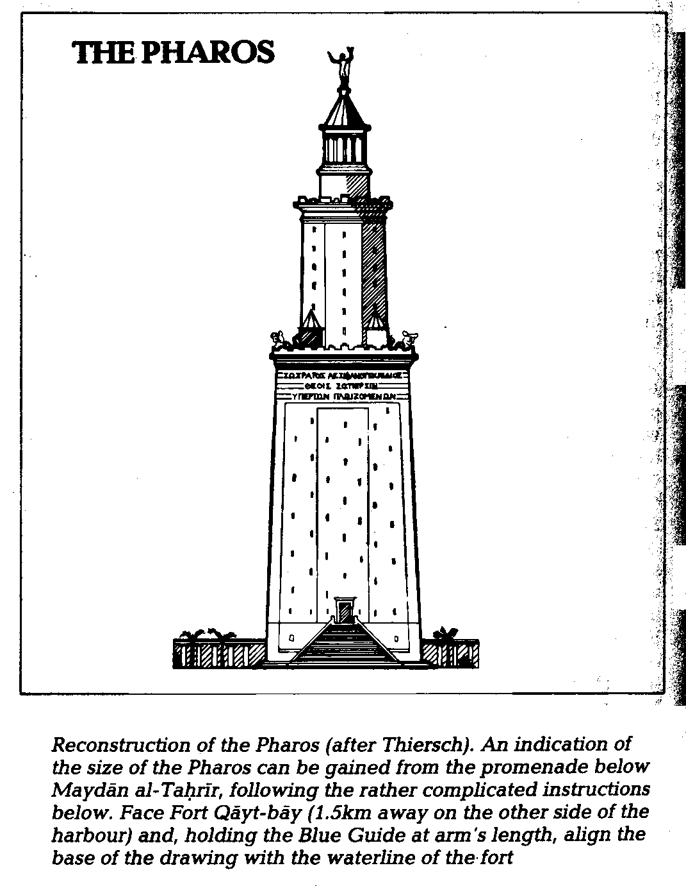

The cultivation of the self is associated with Classical Athens. ‘Philosophy heals human diseases, diseases produced by false beliefs.’(Nussbaum 1994: 14)

Higher learning in Athens provided a basis for the earliest manuals of self-improvement. During the Hellenistic period, the Greek philosophers turned their attention to the details of everyday life, that is, the correct way for free men to behave in the daily running of their household. The detailed descriptions are available in a wide variety of texts, beginning with Plato’s symposium and running into Roman times. Foucault introduces the third volume of his history of sexuality with a detailed account of Artemidorus’ Interpretation of Dreams, one of many self-help manuals available in the classical world. The readership for such books was the literate male elite: slaves and women had much more in common with each other than they had with their husbands, fathers and owners. Slaves and Women in the Greco-Roman World. From time to time the question would arise whether women should be educated, but the issued remained largely hypothetical. The Hellenistic notion of the ‘self’, and how it should be managed, has been the subject of two authors with contrasting views. Michel Foucault is interested to know what views of sexuality existed in the pre-Christian world. His incomplete, three-volume History of Sexuality is much closer to a conventional narrative account than much of his previous writing. He discerns some subtle differences between Greek and Roman attitudes to sexuality, but overall is surprised by the extent to which the classical view of human sexuality did not differ greatly from what came afterwards in the Christian era. Martha Nussbaum is interested in the Hellenistic ideas of leading the good life. She particularly wants to understand how Socratic philosophy was put into practical use by the Stoics and other groups. Following the work of Sir Kenneth Dover, Nussbaum summarised the sexual life of ancient Greek males: ‘It is no exaggeration to say that in the ancient world our modern conception of the homosexual really did not exist, since people did not classify themselves, and others, on the basis of a binary division focused on the gender of object choice. Bisexual desire was assumed to be ubiquitous, and gender of object was simply far less significant than the choice of the active or the passive role. Male-male relationships, furthermore, were seen to be, and often clearly were, vehicles of intense romantic devotion, frequently combined with refined intellectual and political aspirations.’(Nussbaum 1997: 237)
Roman Higher Education

Universities have existed for hundreds of years, and have provided a reflective space for various kinds of societies. We know what kind of society would exist without universities. It might be successful materially and intellectually, but it would not survive. It would be like Ancient Rome. Despite their great wealth, the Romans did not create institutions of higher learning which would rival those of ancient Athens. Indeed, it could be argued that their empire was weaker for lack of a process of self-critique.

The Romans, despite their great wealth, did not value higher education to the same extent as the Greeks, and relied instead on a domestic method of training. Cicero’s life was typical of this style of preparation, and it is generally agreed that by the end of the Republican period, the quality of education Cicero had received was no longer in evidence. (Castle 1961: 148-153). What was produced was an entirely utilitarian education, with little scope or capacity for reflective and critical thinking. Cicero’s own education had been well-rounded, and he valued the artes liberales, including ‘geometry, astronomy, music, rhetoric, dialectics, literature, history, and philosophy’. He studied at the Athenian Academy under Antiochus of Ascalon, Philo’s successor, in the early seventies. (Mitchell 1991: 19-20).

Roman society was preoccupied with doing rather than being. The quintessential Roman contest was not the philosophical debate, but the gladiatorial fight. The gladiators loomed large in the collective mentality of the Romans. Gladiators originally represented the most debased figures in this society; by the imperial period, half the gladiators were volunteers, including people who were freeborn and nobility. To appear in the arena was to slip into a socially acceptable role, and the proof of one’s virtue was to offer one’s neck when defeated and to die honorably. The gladiator offered an insight into the truth of death for a society which had become thoroughly alienated. (Carlin 1993: Ch 1).

Plato’s Academy was absorbed into the larger Roman society, and there was no continuous link between the classical centres of learning and the medieval universities. (Cobban 1975: 21-22)

In 529 AD Plato's Academy was finally closed, by order of the Emperor Justinian. But in fact its influence was well established and would continue well into the medieval period.

The Socratic way has been well summarised by the contemporary American philosopher and classicist Martha Nussbaum, who would recommend it as a general ideal of university education even two millennia later, and argues that it lies at the heart of liberal studies in the US system: ‘The central task of education, argue the Stoics following Socrates, is to confront the passivity of the pupil, challenging the mind to take charge of its own thought. All too often, people’s choices and statements are not their own. Words come out of their mouth, and actions are performed by their bodies, but what those words and actions express may be the voice of tradition or convention, the voice of the parent, of friends, of fashion. This is so because these people have never stopped to ask themselves what they really stand for, what they are willing to defend as themselves and their own. They are like instruments on which fashion and habit play their tunes, or like stage masks through which an actor’s voice speaks. The Stoics hold, with Socrates, that this life is not worthy of the humanity in them, the capacities for though and moral choice that they all possess.’(Nussbaum 1997: 28-29)

READINGS

Anderson, Perry, Passages from Antiquity to Feudalism, Verso, London, 1974.

Barton, Carlin A., The Sorrows of the Ancient Romans: The Gladiator and the Monster, Princeton University Press, Princeton NJ, 1993, ch.1.

Castle, E.B., Ancient Education and Today, Penguin, Harmondsworth, 1961, p.56.

Clarke, M, L., Higher Education in the Ancient World, Routledge & Kegan Paul, London, 1971.

Cobban, A.B., The Medieval Universities: Their Development and Organization. Methuen & Co., London, 1975, pp.21-22.

Kraut Richard, ed., The Cambridge Companion to Plato, Cambridge University Press, Cambridge UK, 1992.

MacArthur, Brian, The Penguin Book of Historic Speeches, Penguin, 1995.

Mitchell, Thomas N., Cicero: The Senior Statesman, Yale University Press, New Haven CT, 1991, pp.19-20.

Morgan, Tersea (1998) Literate Education in the Hellenistic and Roman Worlds, Cambridge University Press.

Nails, Debra, Agora, Academy, and the Conduct of Philosophy, Kluwer, Dordrecht, 1995.

Smith, Helena, ‘Diggers discover ancient secrets’, Herald-Sun, 19 January 1997, p.36, ‘Reviving Athens’ ancient heart’, Age, 18 February 1997, p.A8.

Stone, I.F. The Trial of Socrates, Little, Brown, Boston, 1988.

Wertheim, Margaret, Pythagoras’ Trousers: God, Physics and the Gender Wars, Random House, New York, 1995, pp.22-24

26 July 2001

